FREE TCOLE TRAINING
BELOW 100: HEART OF THE BADGE


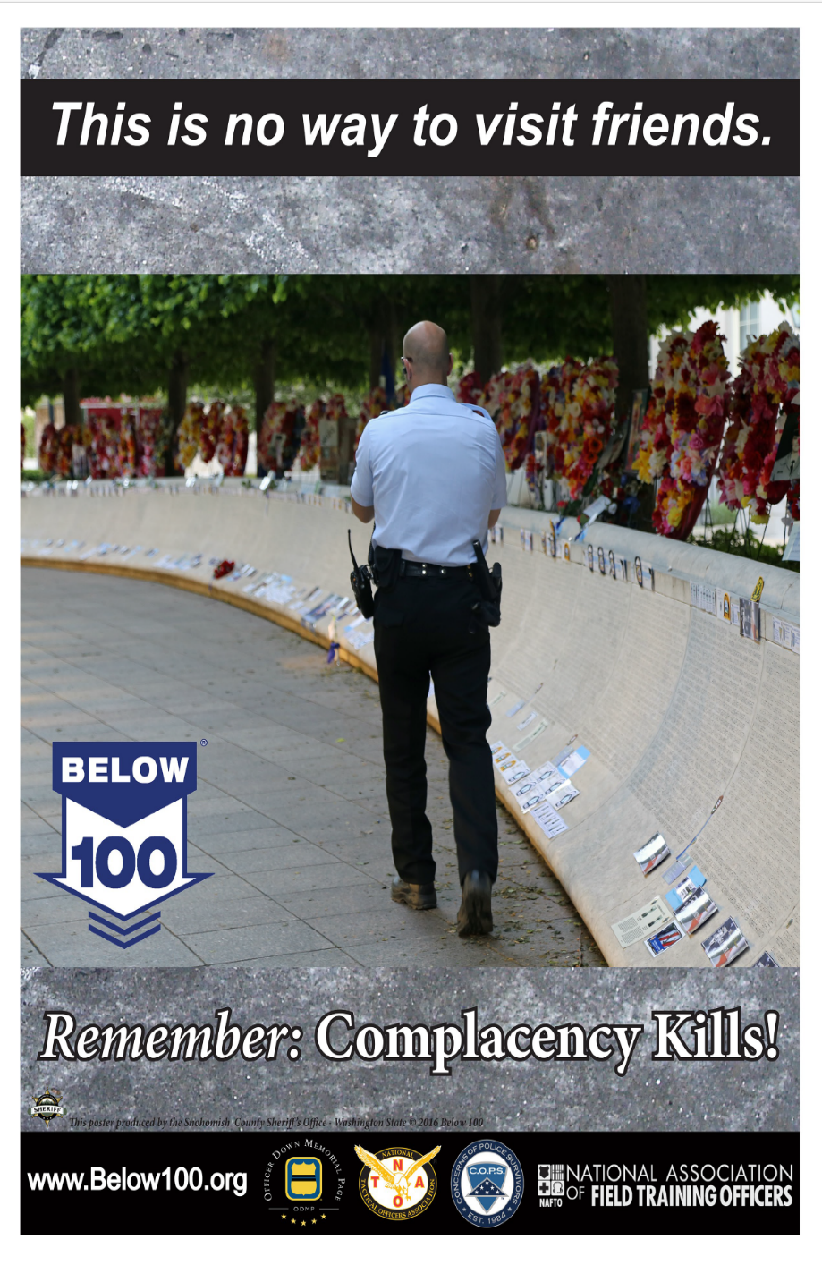
Com
CONTACT
Katie Alexander/ katie.alexander@txlel.org/ 832-527-2170

Scan the QR Code to schedule your Complimentary Heart Disease Screening. It’s a simple, quick, non-invasive test that can save your life! Sponsored by:


COMPLACENCY KILLS IN MORE THAN ONE WAY!

REGISTRATION
Click the link or Scan the QR Code
https://form.jotform.com/252951373928164

November 20, 2025
Marriott Courtyard
22742 Holzwarth Rd
Spring, Texas

AGENDA
Free Intensive: 8:00 AM-12:00 PM
Free Lunch: 1:00 PM–5:00 PM
Free Train the Trainer: 1:00 PM–5:00 PM
Heart Screeining: All Day

