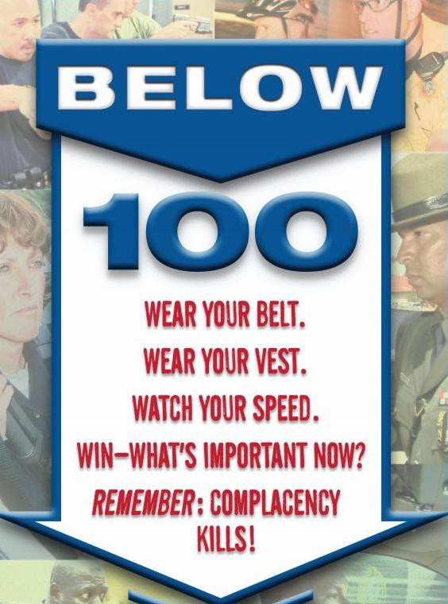

SPONSORED BY THE Washington State Patrol
Kirkland Police Department and National Tactical Officers Association
FREE TRAINING
Law Enforcement Personnel Only

Multiple 4 Hours Sessions Available
February 24, 25, 26, 2016
Each Day - Morning 0800-1200
Afternoon Sessions 1300-1700

Classes held at the
Kirkland Justice Center
11750 NE 118th St, Kirkland WA 98034

“The Life You Save May Be Your Own!”

To register: Contact Ms. Terra Shin, Washington State Patrol at: E-mail: Terra.Shin@wsp.wa.gov OR phone: 425-401-7776. Limited seats available per class.
We can seat 48 – 50 students per session.
The training sessions break down:
Wednesday- February 24: 2 Training Sessions: 8:00 AM – 12:00 PM and 12:00 PM – 4:00 PM
Thursday- February 25: 1 Training Session 8:00 AM – 12:00 PM - 1 Train the Trainer Session 1:00 PM – 5:00 PM
Friday- February 26: 2 Training Sessions: 8:00 AM – 12:00 PM and 1:00 PM – 5:00 PM

